Whatever hour you woke there was a door shutting. From room to room they went, hand in hand, lifting here, opening there, making sure--a ghostly couple.

"Here we left it," she said. And he added, "Oh, but here tool" "It's upstairs," she murmured. "And in the garden," he whispered. "Quietly," they said, "or we shall wake them."

But it wasn't that you woke us. Oh, no. "They're looking for it; they're drawing the curtain," one might say, and so read on a page or two. "Now they've found it,' one would be certain, stopping the pencil on the

margin. And then, tired of reading, one might rise

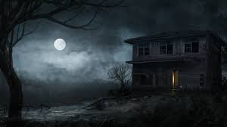and see for oneself, the house all empty, the doors standing open, only the wood pigeons bubbling with content and the hum of the threshing machine sounding from the farm.

"What did I come in here for? What did I want to find?" My hands were empty. "Perhaps its upstairs then?" The apples were in the loft. And so down again, the garden still as ever, only the book had slipped into the grass.

But they had found it in the drawing room. Not that one could ever see them. The windowpanes reflected apples, reflected roses; all the leaves were green in the glass. 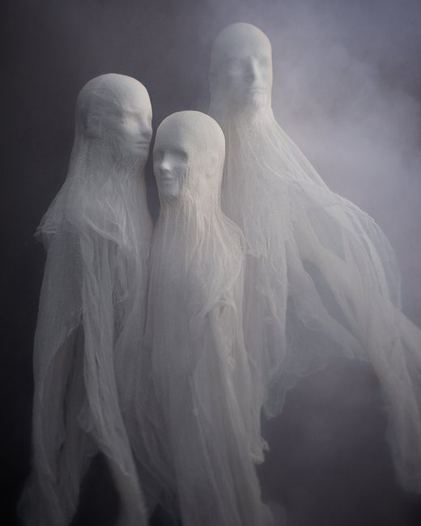If they moved in the drawing room, the apple only turned its yellow side. Yet, the moment after, if the door was opened, spread

about the floor, hung upon the walls, pendant from the ceiling--what? My hands were empty. The shadow of a thrush crossed the carpet; from the deepest wells of silence the wood pigeon drew its bubble of sound. "Safe, safe, safe" the pulse of the house beat softly. "The treasure buried; the room . . ." the pulse stopped short. Oh, was that the buried treasure?

A moment later the light had faded. Out in the garden then? But the trees spun darkness for a wandering beam of sun. So fine, so rare, coolly sunk beneath the surface the beam I sought always burned behind the glass. Death was the glass; death was between us, coming to the woman first, hundreds of years ago, leaving the house,

**9**

sealing all the windows; the rooms were darkened. He left it, left her, went North, went East, saw the stars turned in the Southern sky; sought the house, found it dropped beneath the Downs. "Safe, safe, safe," the pulse of the house beat gladly. 'The Treasure yours."

The wind roars up the avenue. Trees stoop and bend this way and that. Moonbeams splash and spill wildly in the rain. But the beam of the lamp falls straight from the window. The candle burns stiff and still. Wandering through the house, opening the windows, whispering not to wake us, the ghostly couple seek their joy.

"Here we slept," she says. And he adds, "Kisses without number." "Waking in the morning--" "Silver between the trees--" "Upstairs--" 'In the garden--" "When summer came--" 'In winter snow time--" "The doors go shutting far in the distance, gently knocking like the pulse of a heart.

Nearer they come, cease at the doorway. The wind falls, the rain slides silver down the glass. Our eyes darken,

we hear no steps beside us; we see no lady spread her ghostly cloak. His hands shield the lantern."Look," he breathes. "Sound asleep. Love upon their lips."

Stooping, holding their silver lamp above us, long they look and deeply. Long they pause. The wind drives straightly; the flame stoops slightly. Wild beams of moonlight cross both floor and wall, and, meeting, stain the faces bent; the faces pondering; the faces that search the sleepers and seek their hidden joy.

**10**

"Safe, safe, safe," the heart of the house beats proudly. "Long years--" he sighs. "Again you found me." "Here,"

she murmurs, "sleeping; in the garden reading; laughing, rolling apples in the loft. Here we left our treasure--" Stooping, their light lifts the lids upon my eyes. "Safe! safe! safe!" the pulse of the house beats wildly. Waking, I cry "Oh, is this your buried treasure? The light in the heart."